**Fifa World Cup Qualifiers 2018**

The aim of this web project is to simplify the way in which one can view the FIFA World Cup Qualifiers using SVGS, HTML, CSS, JS, Bootstrap and Git.

The project functions in the following way.The user can directly choose the federation he wishes to view

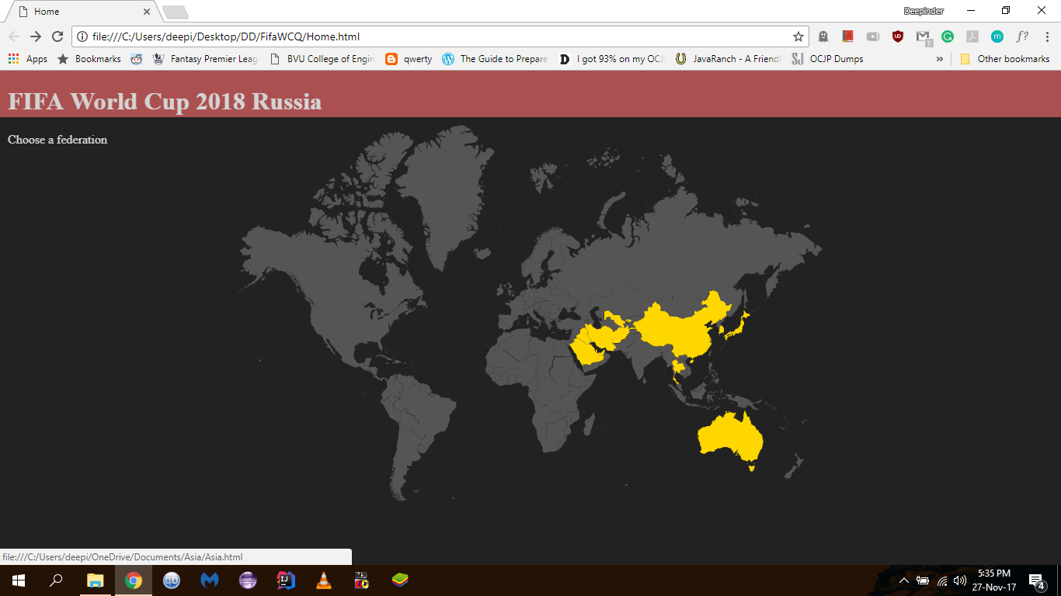

Once a federation is chosen he is presented with a map of the federation along with the current status of the federation members in the qualifying process.

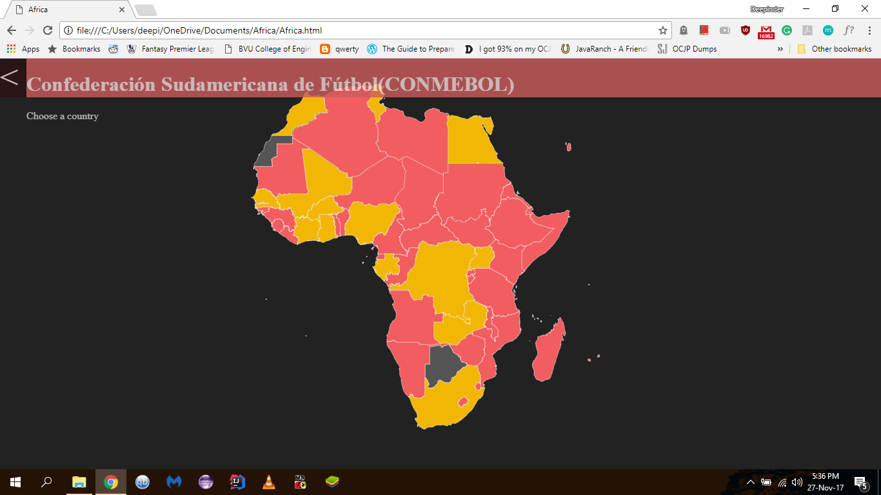

The user can further choose a country and view the recent and upcoming fixtures. Squad info is also available on this page.

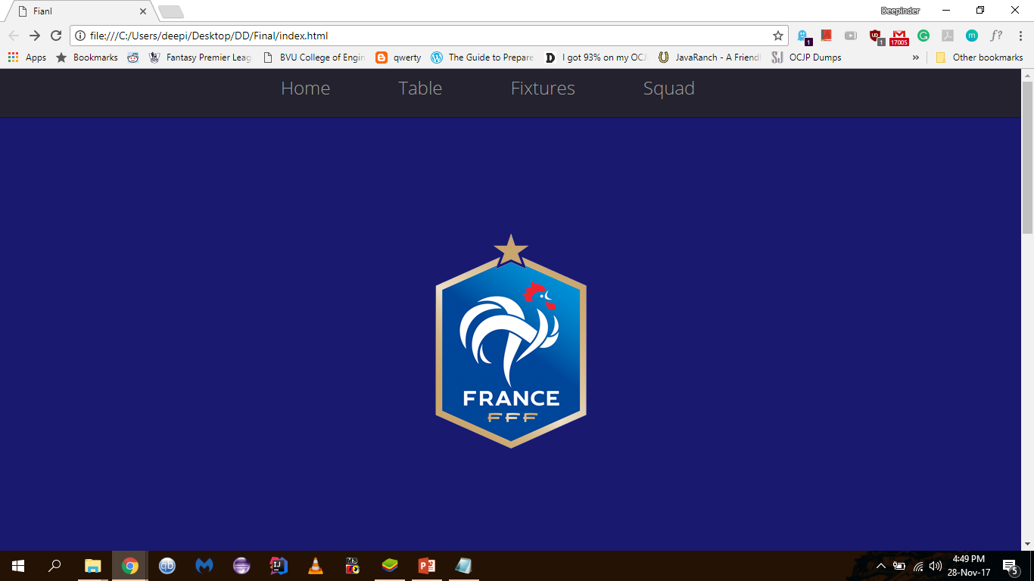

Squad:

